Earth fault detect

# Introduction:

Earth fault is a contact occurs between the live conductor and earth/ground ,so that the current flow directly to the ground . Such faults can cause objectionable circulating currents result in power losses, or may energize the housings of equipment at a dangerous voltage results in a dangerous electrical shock to users.

# Preliminary design:

Reconnecti-ng switch

5 mins delay circuit

Breakdown relay

Power supply

Ac Current comperator

# Literature review:

## Ac Current comperator:

-RCD (Residual Current Device) circuit

When there is no earth fault the currents in the live conductor and the neutral conductor will be the same. If earth fault occur the current on the live conductor will be greater than the neutral one.

The RCD circuit detects the difference between the two currents and give a signal which we will use in the next stage.

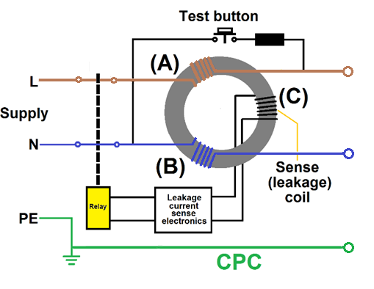

Figure 1 RCD circuit

## 5 mins delay circuit:

Time delay circuits:

-555 timer delay circuits

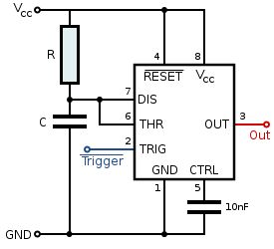

Figure 2 NE555 timer

## OpAmp RC delay circuit

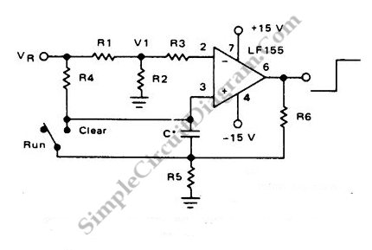

Figure 3 RC delay

With the help of high gain high impedance operational amplifier, we can build a long time delay with resistor-capacitor (RC) circuit since it allow high resistance resistors to be used. We can calculate the time (t) using the following formula; Time (t) = R4.C.ln(Vr/(Vr-Vi)).

## RC MOS time delay circuit

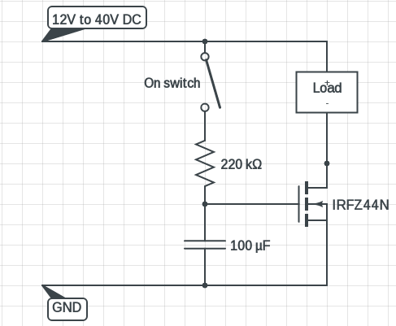

Figure 4 RC MOS delay circuit

This circuit has almost 10 to 12 seconds delay to turn on the load. You can use other MOSFET too, but that should match your requirements.

Another point to note that you could use DC supply with this timer circuit.

In fact RC time constant is not a constant at all, as capacitance can vary as high as ∓30%. So this timers are just for non-critical applications and educational purpose.